PFS study of PIP5KIA based on various parameters in PAAD- Ravi
The analysis was attempted locally on R using TCGA data at first, but the PFS data columns as well as all other columns from which PFS could have been derived were empty (NA) in the downloadable data file. Therefore, I switched to an online tool, TIMER 3 by compbio, which was the same tool used by the original bioinformatician. KM plots for each parameter were plotted using this tool, and the corresponding Hazard ratio and p value for each can be seen on the individual graphs, as well as the summarised table below.
The two parameters in red in the table below showed increased risk (z>0) that was significant (p<0.05), while all other parameters showed non-significance.
Parameter |  | HR | p
Tumor purity | 2 vs 1 | 1.74 | 0.0853
 | 4 vs 3 | 0.761 | 0.362
Stroma score | 2 vs 1 | 0.725 | 0.315
 | 4 vs 3 | 1.21 | 0.519
Immune score | 2 vs 1 | 0.778 | 0.427
 | 4 vs 3 | 0.977 | 0.938
Cancer associated fibroblast | 2 vs 1 | 0.706 | 0.302
 | 4 vs 3 | 1-46 | 0.227
Common myeloid progenitors | 2 vs 1 | 1.05 | 0.887
 | 4 vs 3 | 0.667 | 0.227
Endothelial cells | 2 vs 1 | 0.634 | 0.165
 | 4 vs 3 | 0.748 | 0.319
Tumor CD274 | 2 vs 1 | 0.612 | 0.172
 | 4 vs 3 | 2.78 | 0.0035
Myeloid-derived suppressor cells | 2 vs 1 | 1.14 | 0.682
 | 4 vs 3 | 1.2 | 0.552
Interferon gamma | 2 vs 1 | 0.79 | 0.484
 | 4 vs 3 | 1.38 | 0.287
Common lymphoid progenitors | 2 vs 1 | 1.88 | 0.0437
 | 4 vs 3 | 1.76 | 0.0831
NK cells activated | 2 vs 1 | 1.56 | 0.165
 | 4 vs 3 | 1.31 | 0.363

- Analysis based on Tumour purity (not significant)
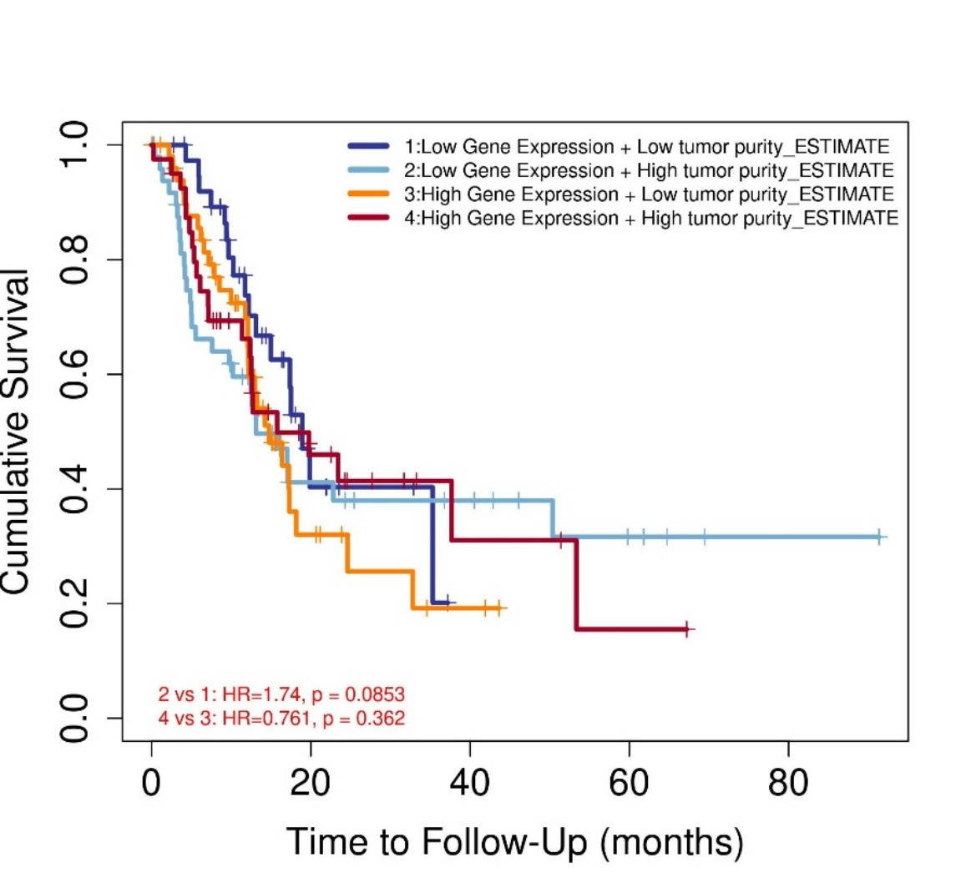
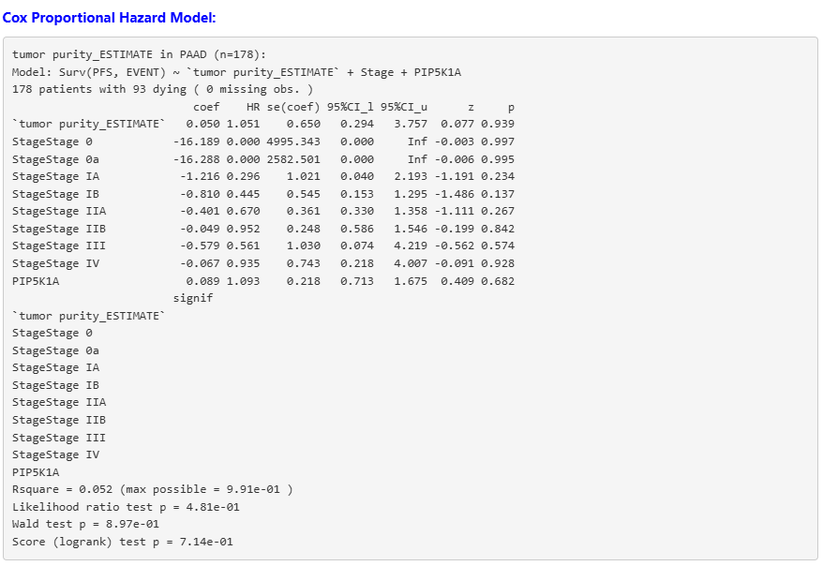

- Analysis based on Stroma Score (not significant)
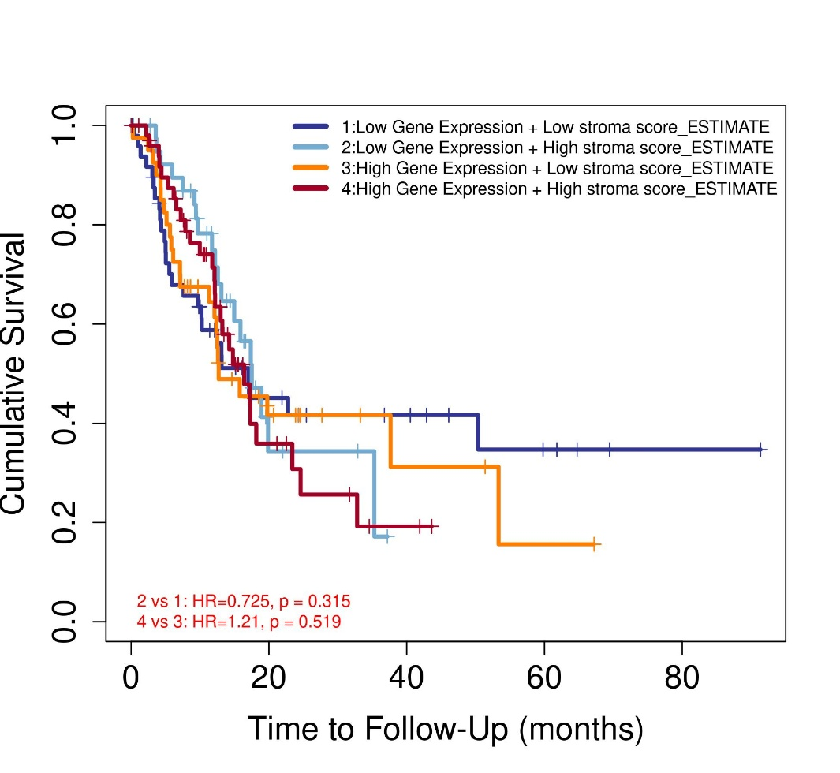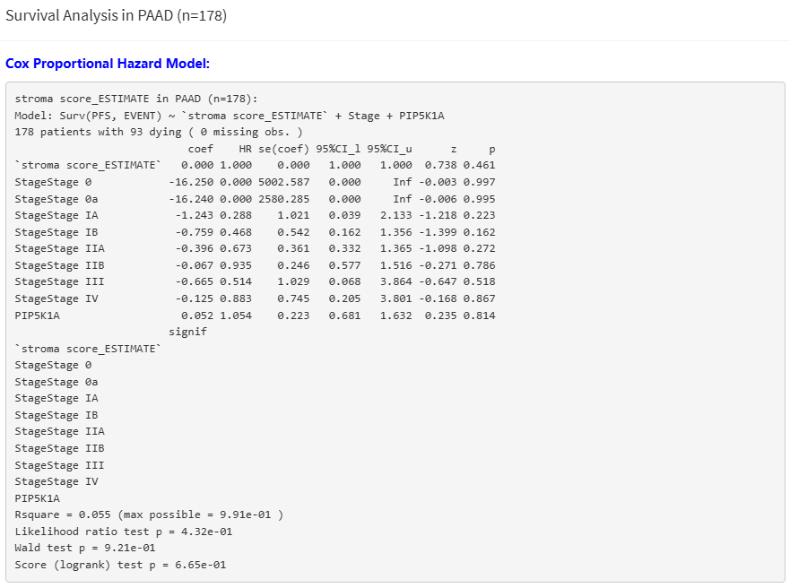

- Analysis based on Immune score (not significant)
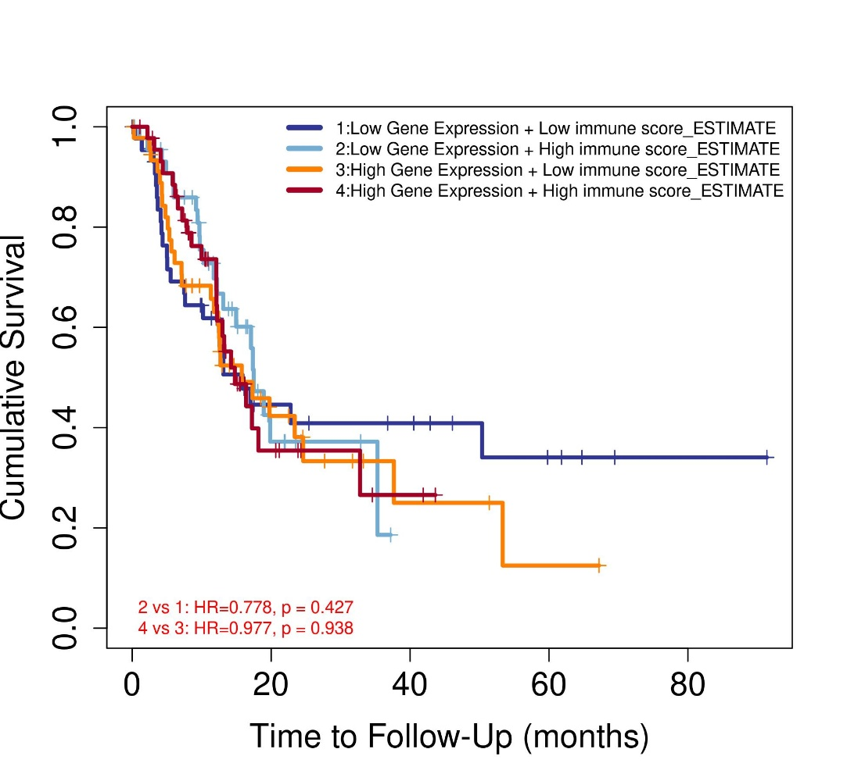
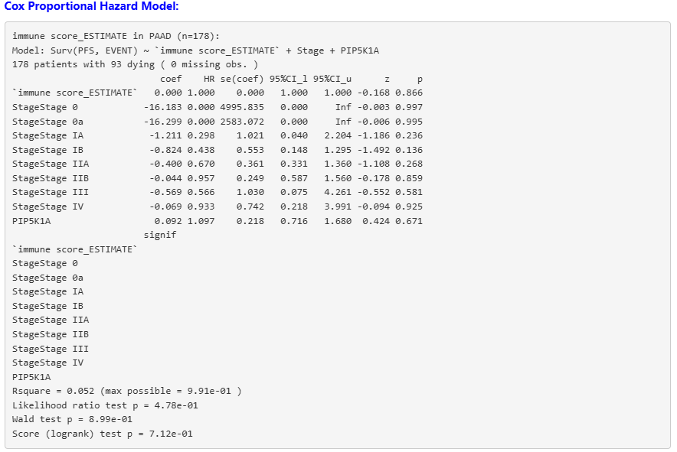

- Analysis based on Cancer associated fibroblast (EPIC) (not significant)
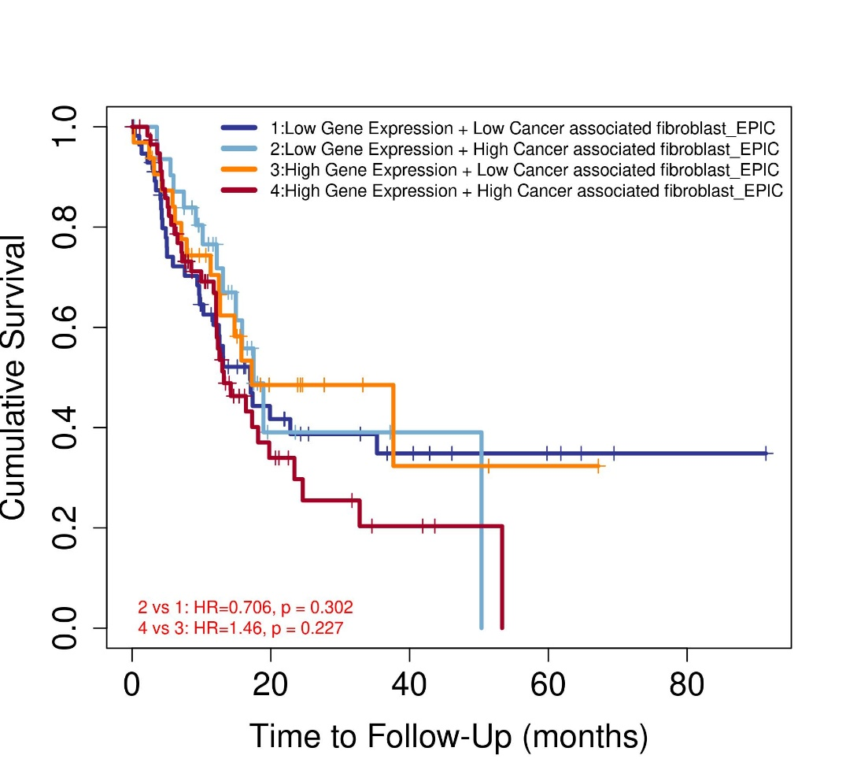
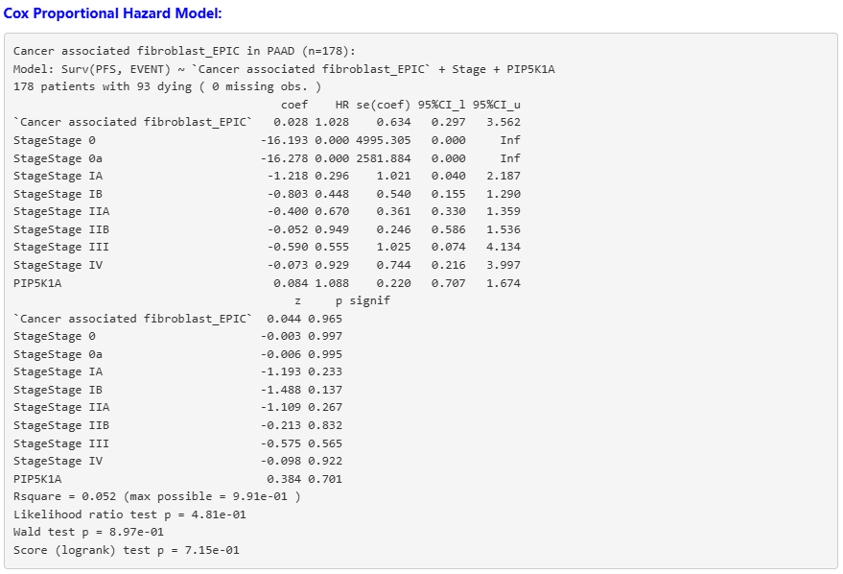

- Analysis based on Common Myeloid Progenitors (not significant)
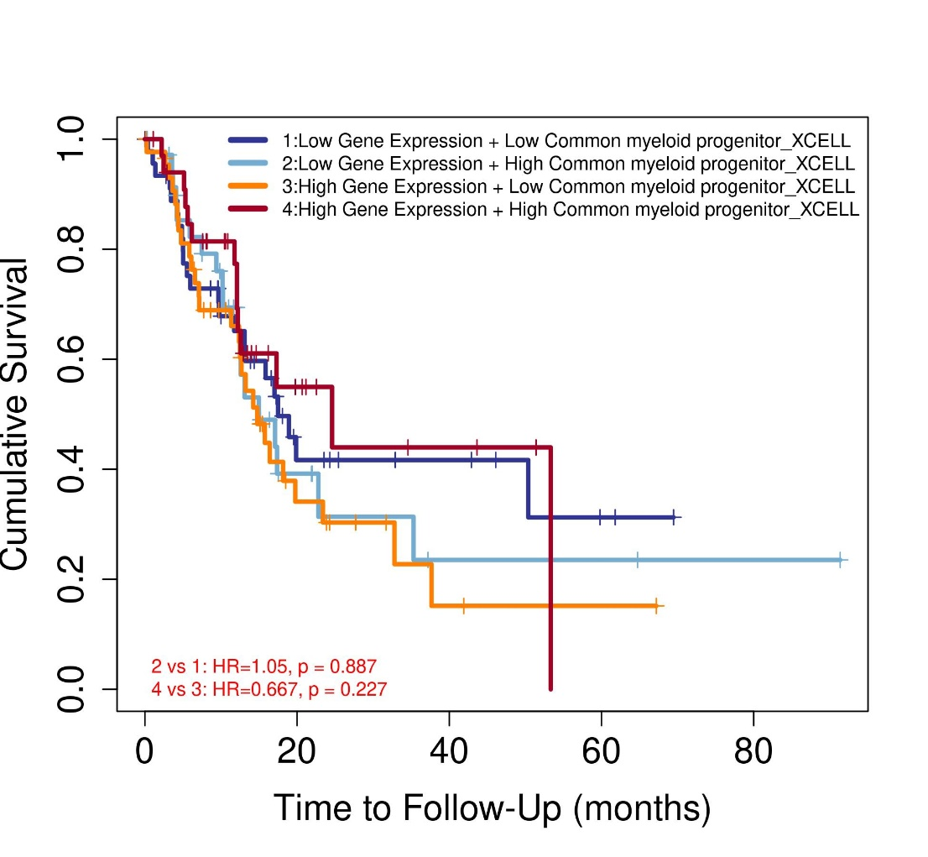
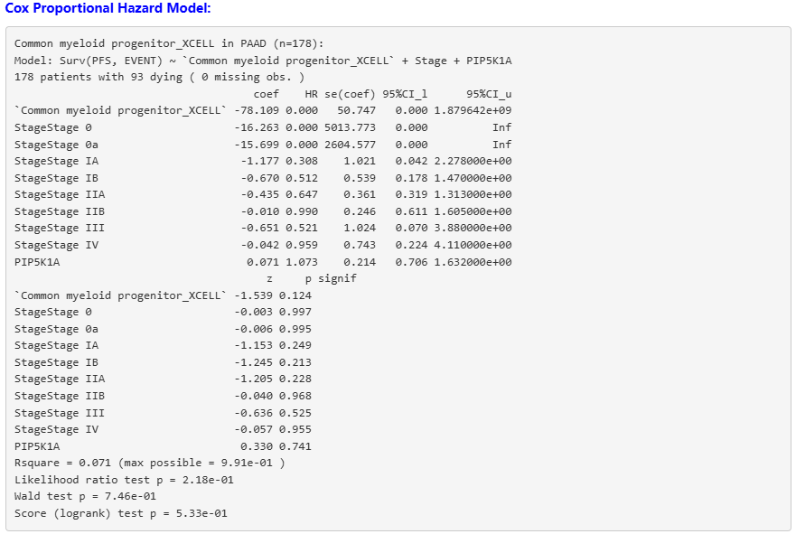

- Analysis Based on Endothelial Cells (EPIC) (not significant)
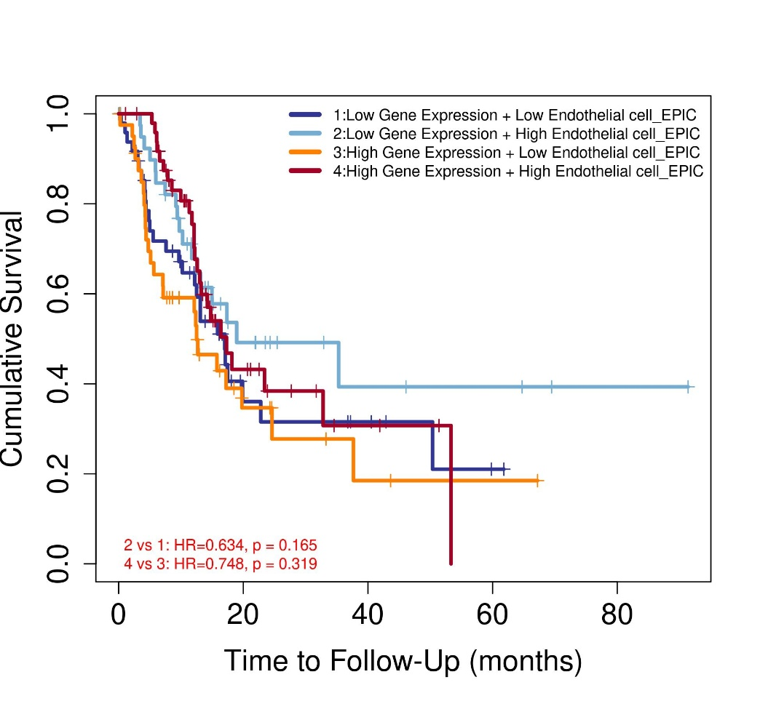
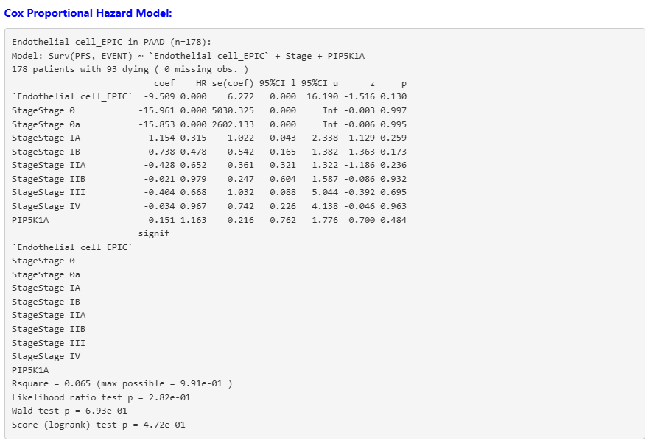
- Analysis based on Tumour CD274 (increased risk)
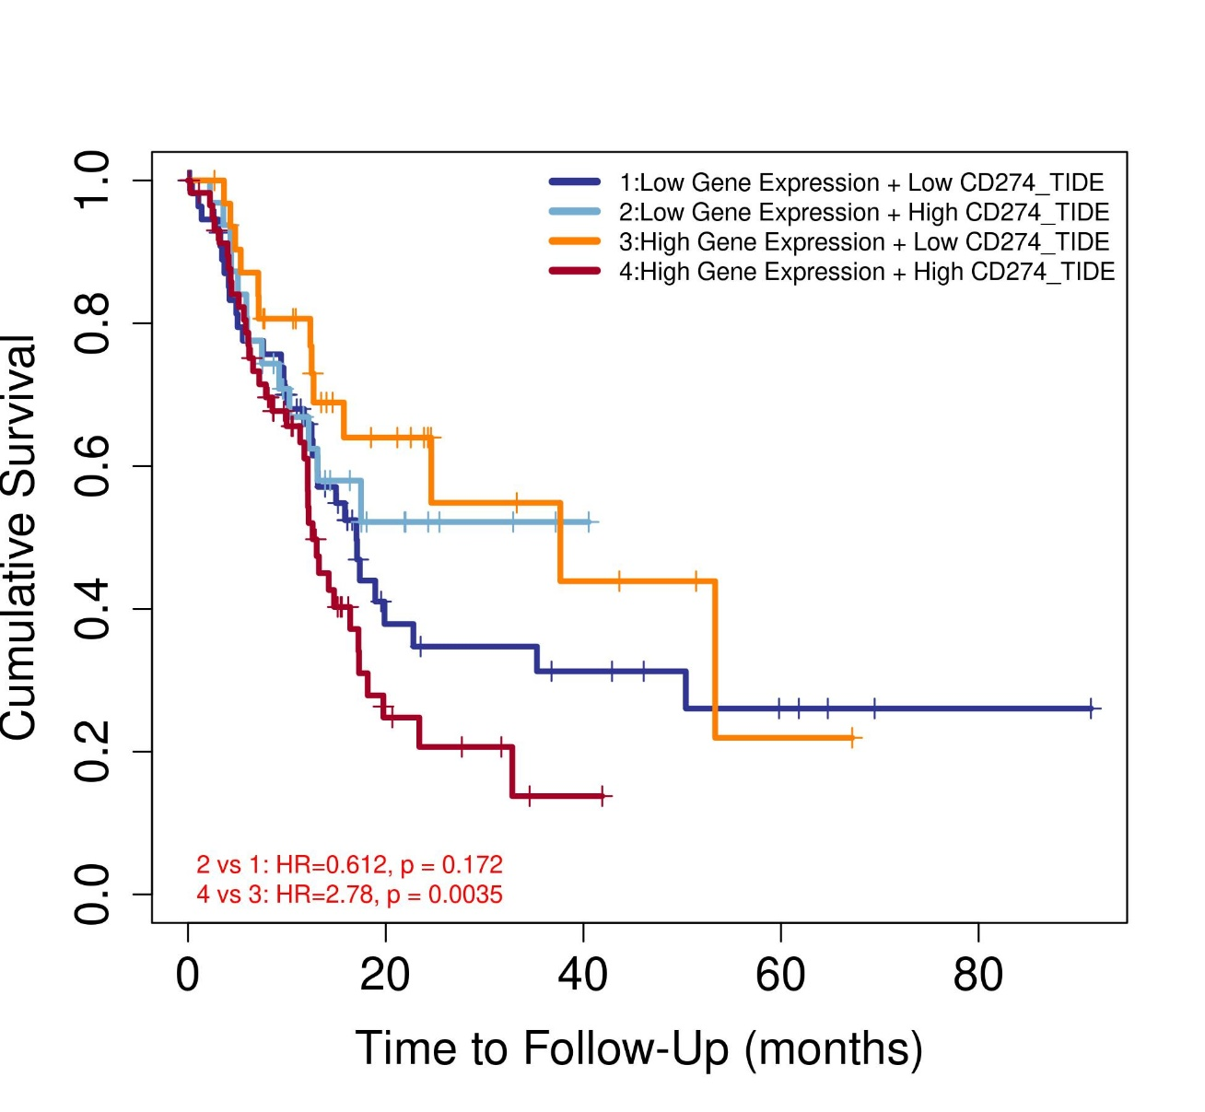
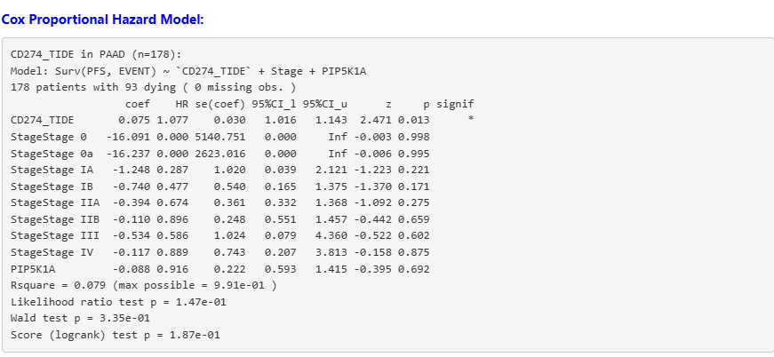

- Analysis based on Myeloid derived suppressor cells (Not significant)
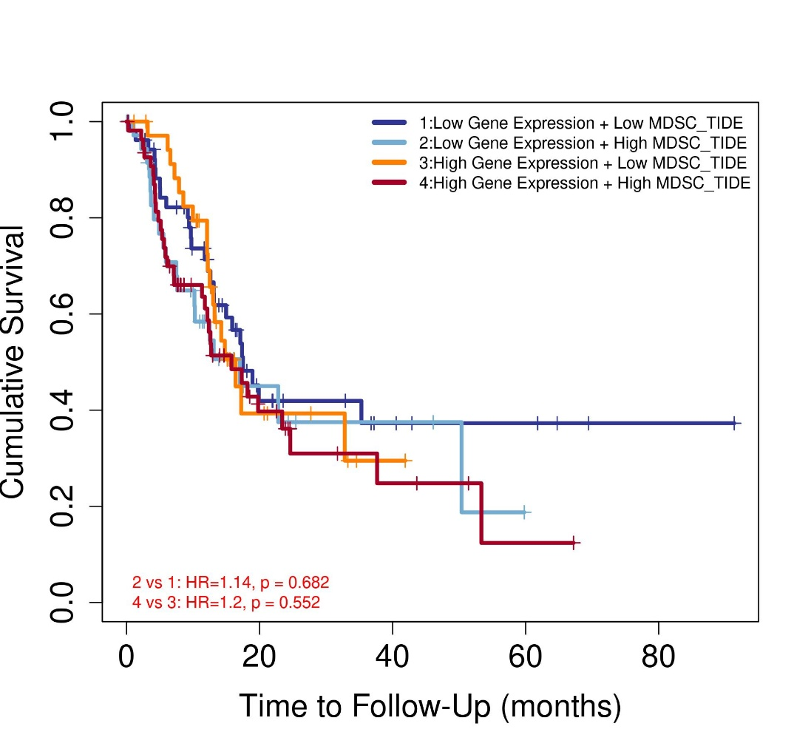
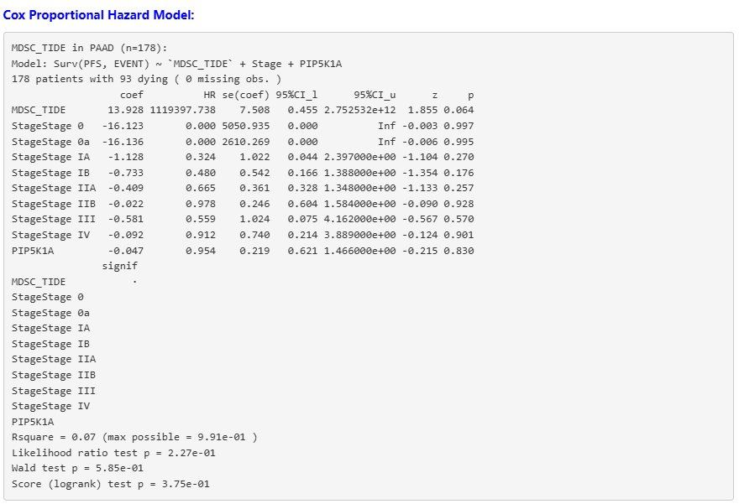

- Analysis based on inferno gamma (not significant)
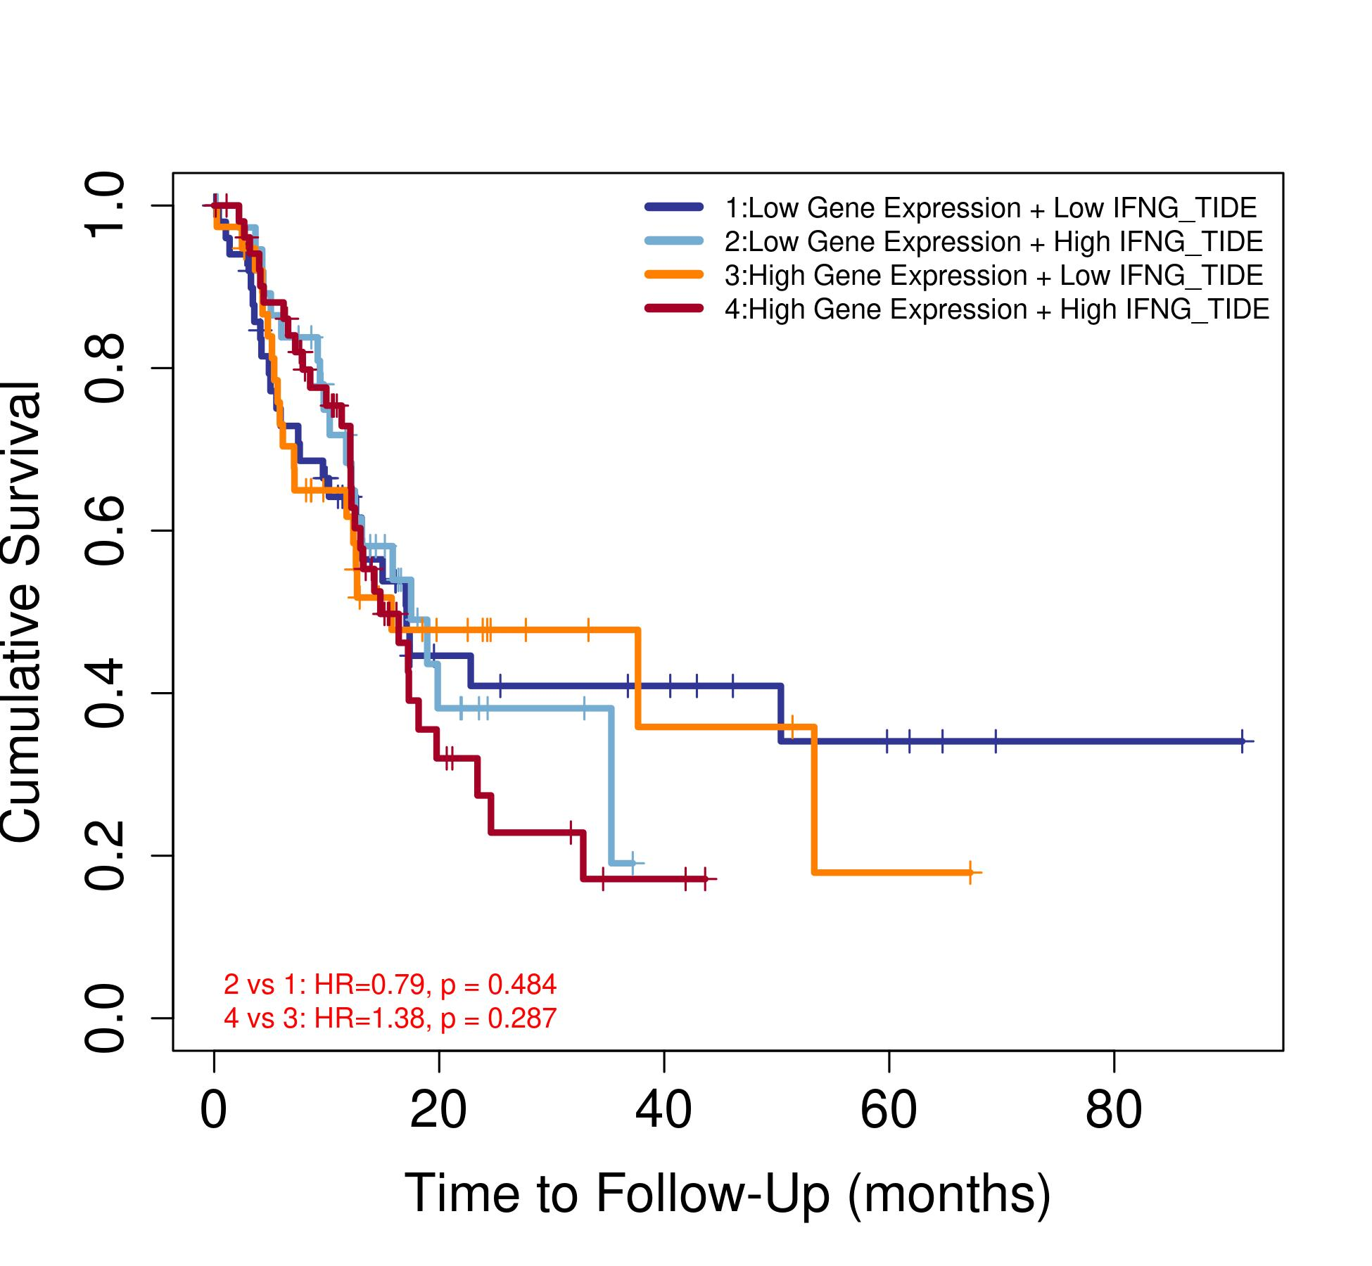
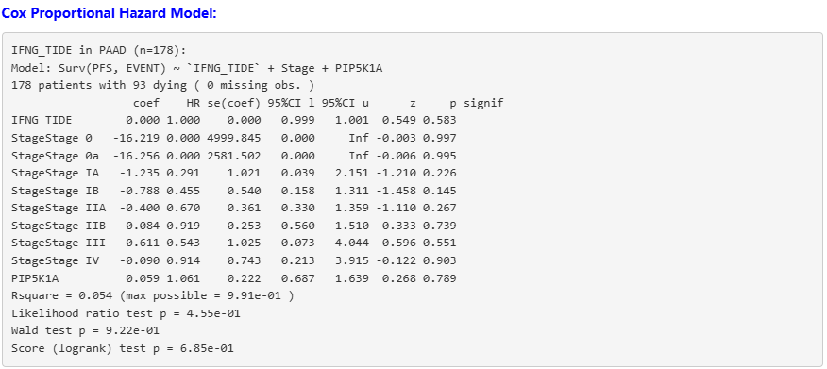
- Analysis Based on common lymphoid progenitors (Increased risk)
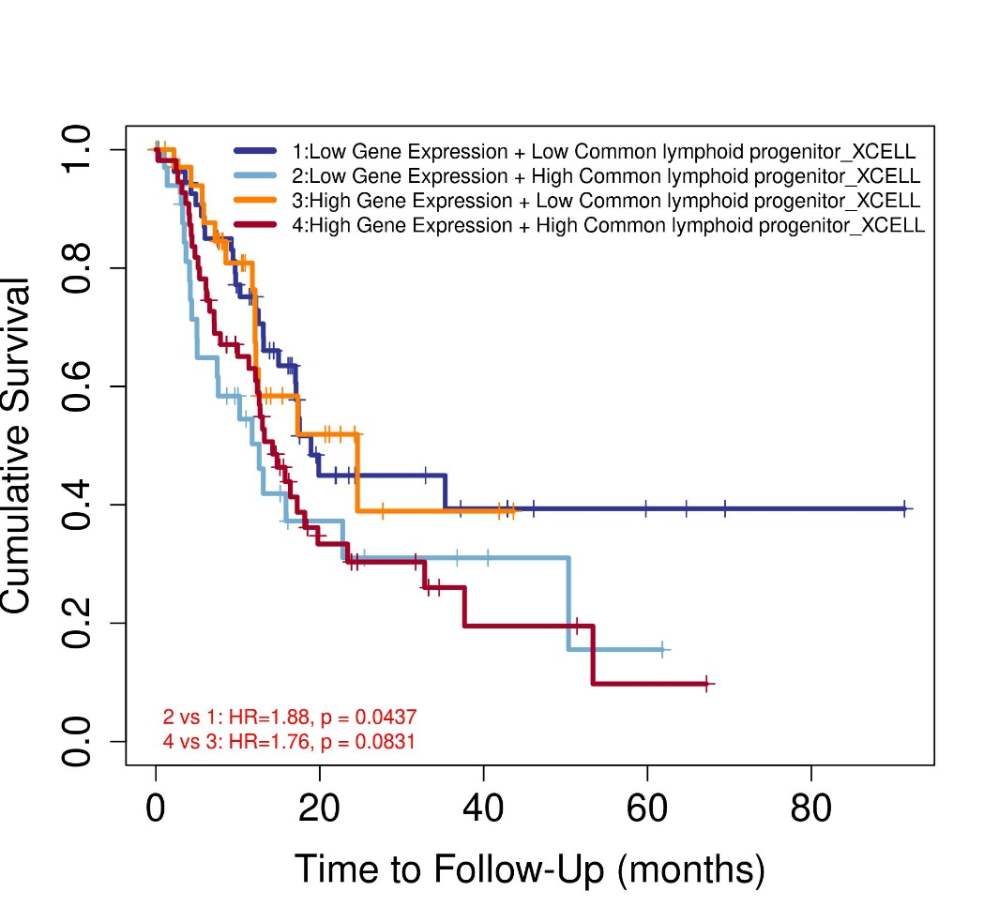
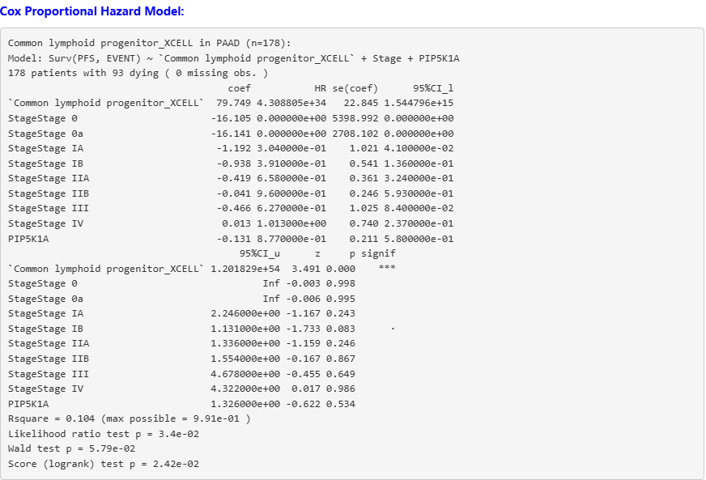

- Analysis based on NK cell activated (not significant)
